***Safe Carz Limitted***

|  |  |  |
| --- | --- | --- |
| **Supervisor.** | Hasnain Ali | |
| **Batch.** | 2407G2 | |
| **Group.** | B | |
| **Serial No.** | **Enrollment Number** | **Student Name** |
| 1. | Student1593069 | Musadiq Khan |
| 2. | Student1597225 | Abdul Rehman |
| 3. | Student1596299 | Abdul Rafay |
| 4. | Student1594542 | Ahtesham-ur-Rehman |
| 5. | Student1597501 | Miza Fateen Baig |
| 6. | Student1599136 | Tabish Muhammad |
| 7. | Student1571556 | Syed Hassan Shehzad |

|  |  |
| --- | --- |
|  |  |
|  |  |
|  |  |
|  |  |
|  |  |
|  |  |

***User Guide***

***1.Welcome (0.Welcome.html)***

***2.Layout Top***



* Home Page (1.Index.html)
* Insurance plan(2. Company-plans.html and vehicle.html)
* About Us Page (3. About Us.html)
* Contact Us Page (4. Contact Us.html)

***3.Layout Bottom.***

***Footer***

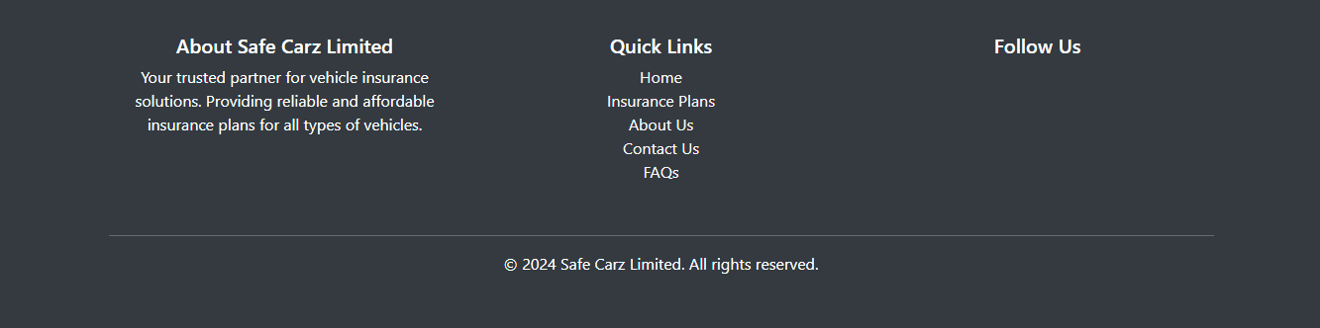

***Figure 5 : Layout Bottom.***

***Figure 6 : Home Page.***

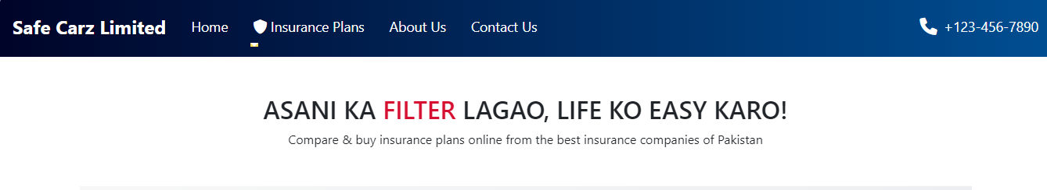***The interface of the Home page is shown as Figure.***

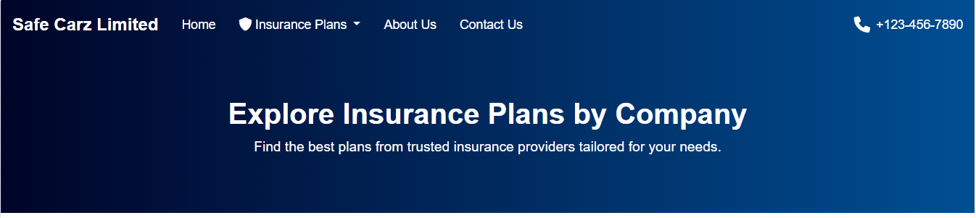 ***Insurance plans page***

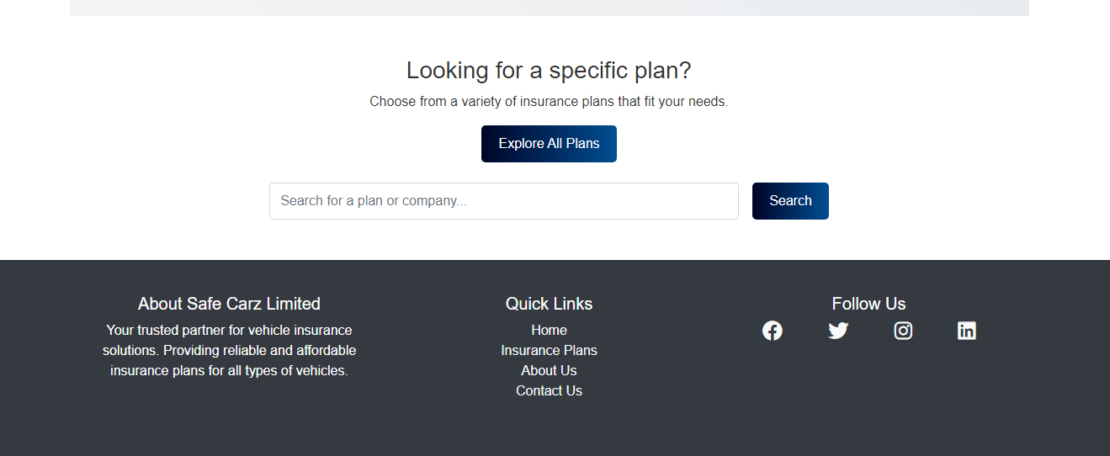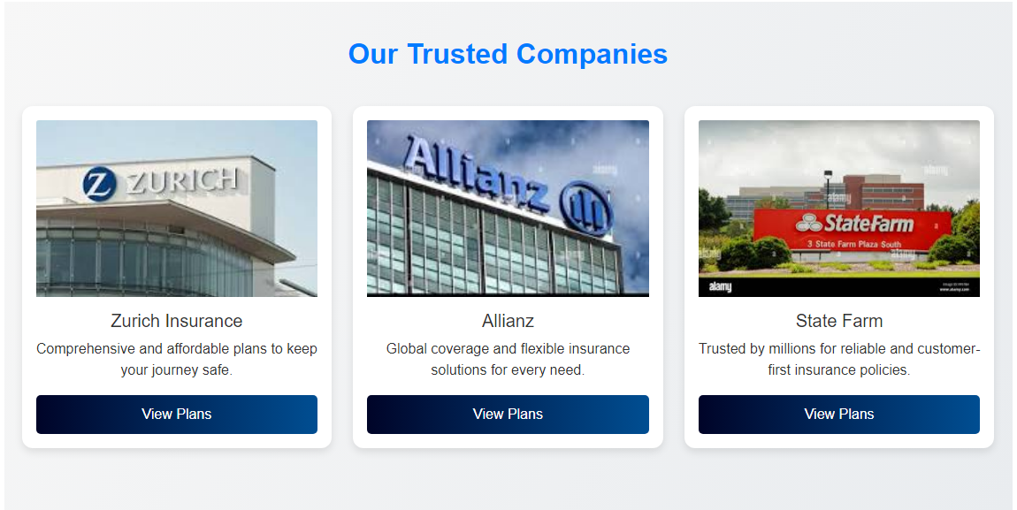

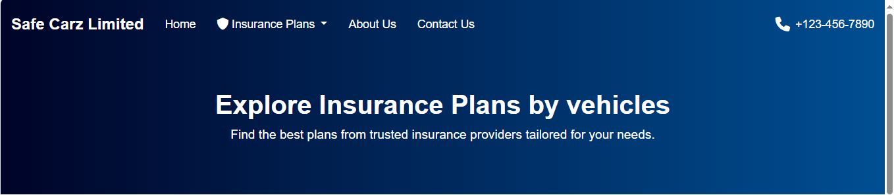***Insurance Vehicle Plans***

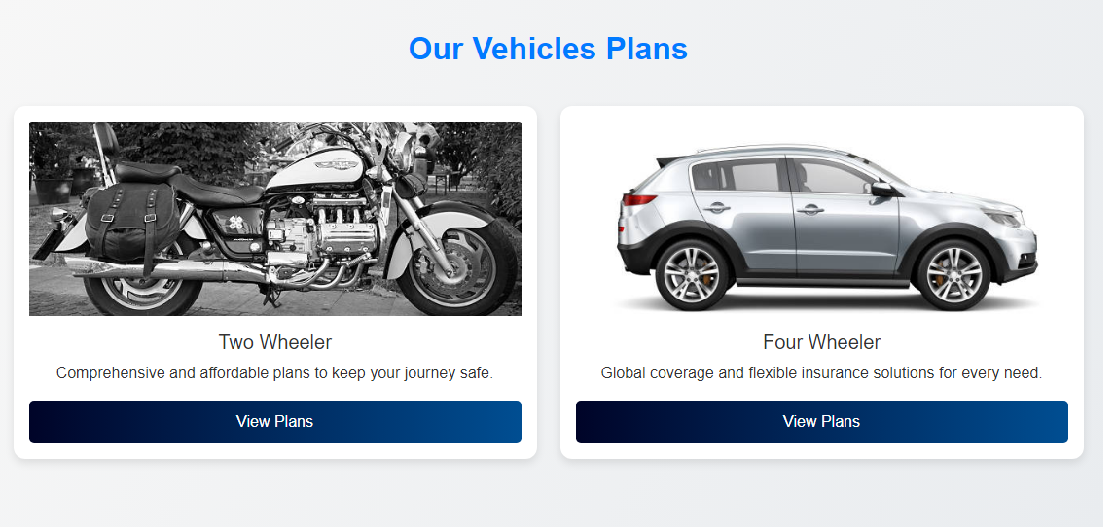

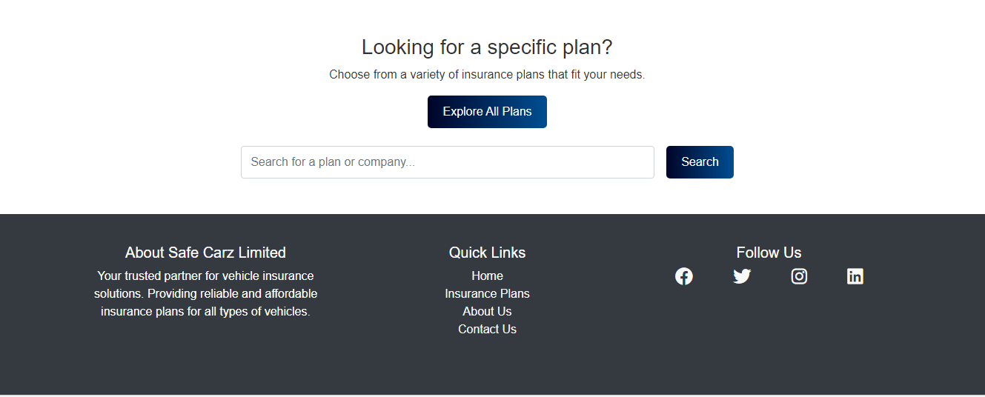

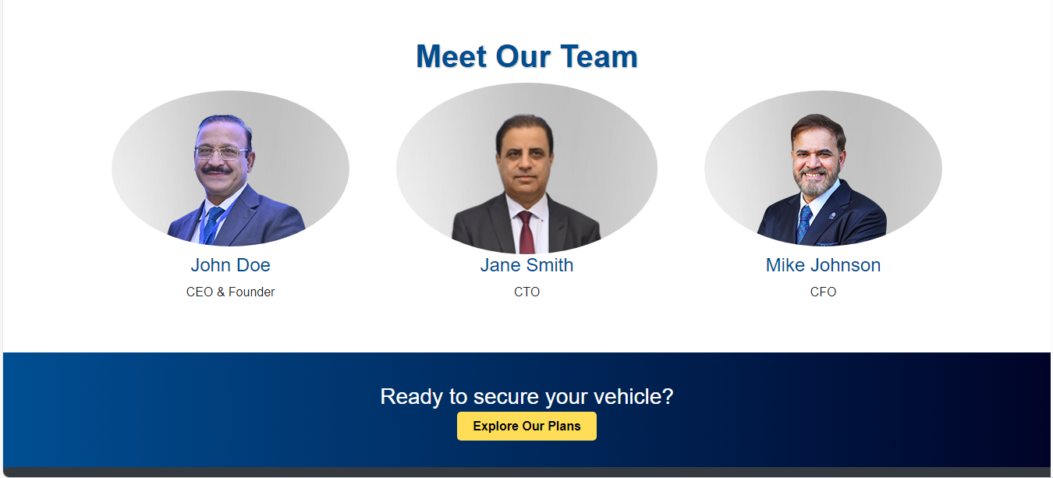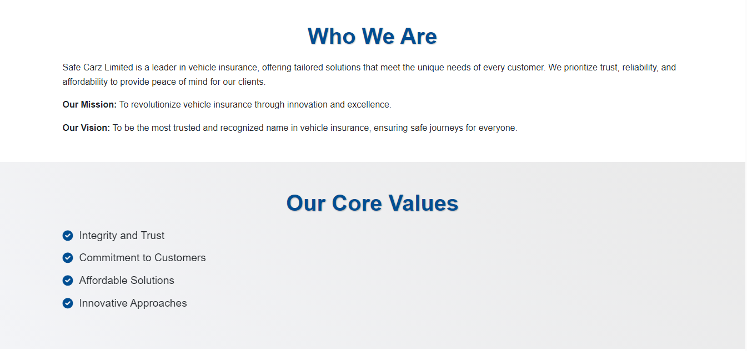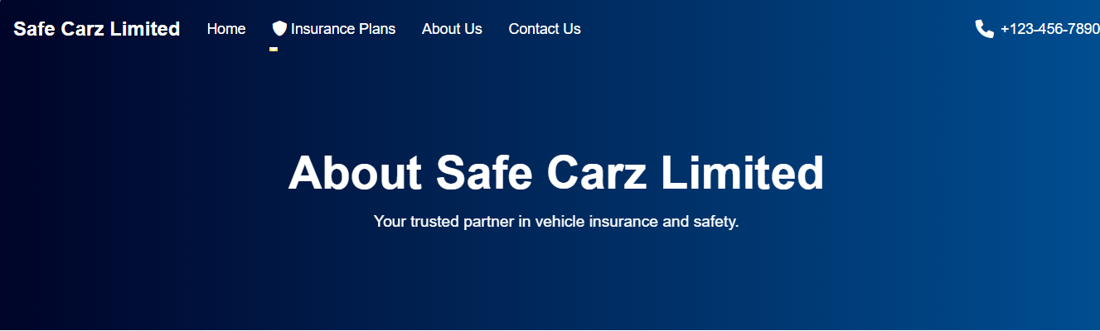**About Page**

**Contact Us Page**



